H1650
Tabletop High Speed Centrifuge

Instruction Manual

(Read the Instruction Carefully Before Operation)

Index………………………………………………………………………………Page
1、Attention for safety....................................................................................................................2
1.1 Attention for installation and maintenance ............................................................................2
1.2 Attention for electric system.....................................................................................................2
1.3 Attention for fireproofing .........................................................................................................2
1.4 Attention for safety in mechanical parts .................................................................................3
1.5 Attention for safety in chemistry and biology ........................................................................3
2、Symbols and meanings...............................................................................................................4
3、Application and scope................................................................................................................4
4、Work theory................................................................................................................................4
5、Classify and name......................................................................................................................5
5.1 Classify .......................................................................................................................................5
5.2 Name ..........................................................................................................................................5
6、Main technical parameters .......................................................................................................5
7、Features.......................................................................................................................................6
8、The structure of main machine, control panel and accessory...............................................6
8.1 The structure of main machine................................................................................................6
8.2 Control panel .............................................................................................................................7
8.3 Accessory.....................................................................................................................................8
9、Installation and adjustment......................................................................................................9
9.1 Installation and its requirements ............................................................................................9
9.1.1 Installation requirements......................................................................................................9
9.1.2 Install centrifuge ...................................................................................................................9
9.2 Adjust centrifuge .....................................................................................................................10
10、Operation.................................................................................................................................10
10.1 Check the rotor and tube.......................................................................................................10
10.2 Install rotor.............................................................................................................................10
10.3 Adding liquid and placing the centrifugal tube..................................................................10
10.4 Close the door lid ..................................................................................................................10
10.5 Set rotor No. speed, time and program No..........................................................................11
10.6 Check RCF.............................................................................................................................12
10.7 Start and stop running..........................................................................................................12
10.8 Take out the centrifugal tube................................................................................................13
10.9 Uninstall the rotor .................................................................................................................13
10.10 Power off...............................................................................................................................13
11、Service and maintenance .......................................................................................................13
12、Common trouble and trouble shooting.................................................................................15
12.1 Common error code...............................................................................................................15
13、Transportation and storage...................................................................................................16
13.1 Transportation ......................................................................................................................16
13.2 Storage ...................................................................................................................................16

Attached: Warranty, Packing list, Quality certificate and Diagram of electric system connection

1、Attention for safety
 Attention for safety clarifies the requirements of safe operation in the instruction manual. Please carefully read it before installation, operation, maintenance and repairing. Understanding the warning and correct operation can avoid the personal injury and the damage of centrifuge.

1.1 Attention for installation and maintenance
·The rotor accessory and package may be placed in the centrifugal chamber. You should open the door lid for checking when installing.
·In the machine maintenance process, the parts that need remove cover may cause electrical shock or personal injury. Ensure that the power has been cut off and the power line has been removed from the socket, and qualified staff manipulates it.
·The replaced part must be consistent with the requirements of this centrifuge.

1.2 Attention for electric system
·To reduce the risk of electric shock, the centrifuge adopts the plug with three points which must connect with the socket with ground lead.
·Make sure if the wall socket is connect with the ground wire. The voltage of power supply must accord with the voltage of centrifuge.
·Don’t use the power adapter from three holes to two holes.
·It is forbidden to use the expanding socket with two lines or all-purpose power adaptor without ground wire.
·Don’t put container with liquid on the centrifuge or around the centrifuge. If the container is knocked over, the liquid will infiltrate into centrifuge and damage the electrical or mechanical parts.

1.3 Attention for fireproofing
·Please use the overload fuse with same model and specification.
·The centrifuge is not designed for the flammable and explosive matters. You cannot make centrifugation for the matters (chloroform, acetaldehyde), and cannot put the matters in the centrifuge or store them around centrifuge within 30cm.

1.4 Attention for safety in mechanical parts
·Please use the rotor and accessories which are designed for this centrifuge
·Make sure if the centrifugal chamber is cleaned before operation.
·Make sure if the screw (nut) of the rotor in the centrifugal chamber has been screwed down.
·Not exceed its max speed of rotor during operation.
·Don’t decelerate rotor speed or stop by hand.
·Don’t hold or move centrifuge when rotor is rotating.
·If the glass test tube is cracked in centrifuge chamber, please carefully check and clean the gasket and centrifugal chamber because the glass fragment may have inserted into their surface.
·Don’t open the door lid of centrifuge in the running status.
·The distance between centrifuge and other objects must be kept 30cm during operation. You should not stand around centrifuge within 30cm unless adjusting it. Anything is not allowed to enter into centrifuge during operation.

1.5 Attention for safety in chemistry and biology
· The routine manipulation may include all kinds of liquid and test sample which may be the disease-causing and poisonous matters. The centrifuge can not be manipulated with the matters unless you have toke the protection measures.
·Please pay attention to the liquid explanation in container before operation.
·Be careful of the infectious liquid. If not understanding the provided sample, please at least make sure that they aren’t microbe. You must make further aerosol protection（the suspended speck in the air, such as smoke and fog.）for the easier disease-causing hepatitis virus(B or C), HIV, atypical mycobacteria and the fungus of physical structure.
·The infectious samples must be manipulated according to the manipulating program and method in lab for avoiding expanding disease.
·The spilt matters may produce aerosol（the suspended speck in the air, such as smoke and fog.）, so please pay attention to the warning about aerosol (the suspended speck in the air, such as smoke and fog.)
·Only use the suitable rotor and adaptor. The centrifuge can not be manipulated with disease-causing, poisonous or radioactive matters unless you have toke the protection measures. When the second type of hazardous substances (according to “Laboratory Biosafety Manual” of the World Health Organization.) is manipulated, the air safety level must be monitored. The superior substances require a higher level of safe protection measurements.
·You should follow the environment security and protection requirements when destroying the discarded liquid.

Users have the responsibility to clean and sterilize centrifuge and accessory if you need maintenance service from our company.

2、Symbol and its meanings
No. | Symbol | GB No. | Meanings
1 | ～ | 4706.1 | Alternating current
2 |  | 5465.2 | Power on(general supply)
3 | ○ | 5465.2 | Power off (general supply)
4 |  | 4728.2 | Protective earthing(ground)
5 |  | 4793 | Warning!

Form 1
3、Application and scope
H1650 tabletop high speed centrifuge makes use of centrifugal settling theory to separate, purify and condense the granule. It can be widely used in the fields of clinical medicine, biochemistry, genetic engineering and radioimmunology. It is ideal equipment for scientific research institute and hospitals.

4、Working Theory
Centrifuge makes use of the strong RCF that centrifuge rotates with high speed in order to accelerate the settling speed of the granule in the liquid, and separate, condense and purify the matters with different settling coefficient and density.
5、Classify and Name
5.1 Classify
·It belongs to Class 1 of medical laboratory equipment according to the management of “The Classified Catalogue of Medical Devices”.
·It belongs to Class 1 of ordinary equipment with protective grounding according to the protection against electric shock.
·It belongs to tabletop centrifuge according to the structure.
·It belongs to high speed centrifuge according to the speed.

5.2 Name
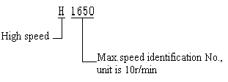
H1650 is tabletop high speed centrifuge whose Max.speed is1650×10r/min.

6、Main technical parameters
Max. Speed: 16500r/min
Max. RCF: 22150×g
Max Capacity: 6x50ml
Speed Accuracy: ±30 r/min
Time Accuracy: 1 min～99min59s
Power: ～240V . 50Hz 5A
Noise: < 65dB(A)
Dimension: 420mm x 325mm x 325mm
Package: 640mm x 385mm x 330mm
Weight: N.W. 20kg G.W. 28kg
Environment Requirement:
Temperature: 10℃～35℃ Relative Humidity: ≤85%
7、Features
· Microprocessor control
· Touch panel and LCD display
· Using PWM speed control mode, with high speed accuracy and rapid acceleration/deceleration function.
· DC brushless frequency-conversion motor to keep the smooth running in quite, and it is not needs to change brush, no carbon dust pollution which meet the requirement of laboratory.
· RCF value can be calculated automatically
· Adopt special shock absorber for ideal effect of vibration damping.
· Electronic lock door for safe operation. The centrifuge will reluctant to work if the lid isn’t closed properly; the centrifuge will stop automatically while the lid is open abnormally during a run.
· Stainless steel multiple brackets for replacing conveniently.

8、The structure of main machine and control board and accessories
8.1 The structure of main machine
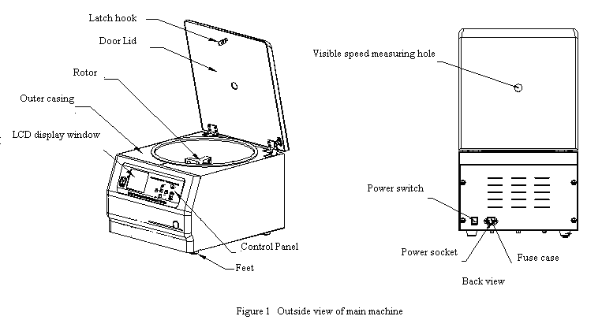
The centrifuge is composed of the main machine and accessories. The main machine is composed of outer casing (which is founded by high strength ABS plastic and insulated/resistant to corrosion), centrifugal chamber, drive system, control system and the part of manipulation display. The rotor and centrifugal tube(bottle) belong to accessory(provide according to contract).

8.2 Control Panel
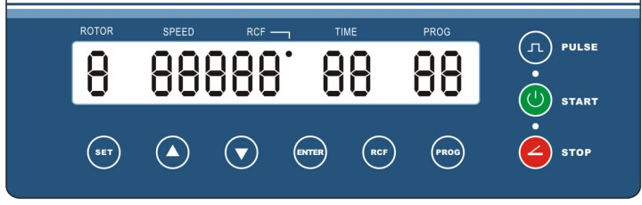

·LCD Display window：
Function of key:
Set: Set the parameter of rotor No., acceleration profile, deceleration profile, speed and time.
PROG: Choice and modify initialize program. The initialize program must be choiced in the state of stop.
▲: Increase key, press “▲” to increase the setting parameter value when set rotor No., acceleration profile, deceleration profile, speed, time etc.
▼：Decrease key, press “▼” to decrease the setting parameter value when set rotor No., acceleration profile, deceleration profile, speed, time etc.
ENTER：Comfirm key to confirm the setup working parameter value of rotor No. speed, time and so on.
START：Press [START] to begin centrifugation after setting and confirming the parameters or repeating the setup parameters last time, and the start indicator light on.
STOP：The key to stop centrifugation and open the door lid. When the centrifuge is working (the time isn’t counted down to “0”), you can stop it by manual and the stop indicator light on. When the centrifuge is in the state of rest and rotor does not run (but the centrifuge is power on), press it to open the door lid.
PULSE：Shortrun key（short-time centrifugation）. Press the key and hold on, then the centrifuge will run swiftly; Release the key, the centrifuge will stop automatically.
·The function of indicator lights:
[START] indicator light: The [START] indicator light is on, which means the centrifuge has started and in the running status.
[STOP] indicator light: The [STOP] indicator light is on, which means [STOP] is pressed or the work time is counted down to “0”. The centrifuge is slowing down for stopping or has stopped.
[PULSE] indicator light: The [PULSE] indicator light is on, which means the centrifuge has started and in short-time centrifugation.

8.3 Accessory
Rotor | Max.speed（r/min） | Capacity (ml) | Max.RCF（×g）
NO.1 Angle rotor | 16500 | 12×1.5/2.2ml | 18930
NO.2 Angle rotor | 13500 | 12×5ml | 12835
NO.3 Angle rotor | 12500 | 12×10ml/5ml | 16060
NO.4 Angle rotor | 11000 | 6×50ml | 12840
NO.5 Angle rotor | 13500 | 6×30ml | 18720
NO.6 Angle rotor | 14000 | 30×1.5ml | 22150
NO.7 Angle rotor | 15000 | 24×1.5/2.2ml | 21532
NO.8 Angle rotor | 13500 | 48×0.5ml | 13810
Form 3

9、Installation and adjustment
9.1 Instrument installation and its requirements:
9.1.1 Installation requirements:
Warning: Don’t install centrifuge in the place with flammable and explosive matters. The flammable and explosive gas comes into the running centrifuge, which may lead to fires.
· The centrifuge should be installed on the flat and solid platform.
· The large free space should be kept around the two sides and back of centrifuge for heat dissipation for ventilation.
· It is prohibited to put lab equipment with large heating production and strong vibration around centrifuge.
· The working environment temperature is 10℃ to 35℃, and the relative humidity is no more than ≤85%.
· Power: ～240 V 50Hz
9.1.2 Install centrifuge
· Open the outer package, carefully take out the centrifuge with foam package, then put it on the even platform and take off the foam package. The four rubber feet of centrifuge should touch with platform evenly.
·Use special tools to open the door from the right holes in chassis, push it hard from right to left, after heard the sounds "dang", lift up door cover until it open up.
· Take out all the things except rotor, and check the centrifugal chamber.
· Check the main machine, accessory, attached tools and documents according to the packing list.
· You should confirm that the voltage of the power supply should be consistent with the voltage the centrifuge requires. (Check the marking beside the electric outlet on centrifuge back, and the instrument’s power requirement is AC 240V 50Hz with single phase and three wires.) Connect the power cord (three wires and 10A) to the electric outlet on centrifuge back first, then put the plug on the other end into the external electric supply socket. Press one side marked “” on the switch to power on.
· If there are any electronic problems, it should be repaired by the professional technicians

9.2 Centrifuge adjustment
Warning: It is forbidden to start before the centrifuge chamber is not cleaned. Otherwise, the centrifuge may be damaged.
According to the operation steps of Chapter 10, first run with low speed, and gradually accelerate to the max.speed. If no abnormal phenomenon happens, you have succeeded in adjustment.

10、Operation
10.1Check the rotor and tube: You should carefully check the rotor, tube or test bottle before operation. It is forbidden to use the cracked and damaged rotor, tube or test bottle. Otherwise, all damages should be borne by user.

10.2 Install Rotor: Aim the slot on the bottom of rotor central hole to the horizontal slot on drive shaft, then place the rotor on drive shaft and make the slot in the pin. Then put on a spacer and make the lock screw into tapped hole on the top of drive shaft, tighten it with screw driver.(The rotor has been installed before delivery, and please check whether the lock screw is tighten.)

10.3 Adding liquid and placing the centrifugal tube: Put centrifugal tubes with adding liquid into the centrifugal tube of rotor (the tolerance of each tube weight with liquid must be less than 2g) and tubes should be placed symmetrically in even number. Otherwise, there will be vibration and noise because of imbalance.

10.4 Close the door lid: Press down the door lid until you hear “clicking” sound which means the door lid pin enter into the hook. Then lift the door lid by hand to check whether it is closed properly. If the door lid can not be opened, it means it is closed properly. If press the [START] key and centrifuge can not run, the buzzer will tweet and “TIME min” window displays [E5] error code which means the door lid is not closed properly. Press [STOP] key to clear the error show, and close the door lid properly again.

10.5 Set rotor number, speed, time, acceleration profiles, deceleration profiles and program number:
·In state of rest, users can set rotor number, speed and time.
·During a run, users can change the setup parameters of speed and time under current program number.
(1)、Select, store and modify the preset program.
a. Program using: In the stopping status, press “PROG” once and the “” (PROG and digit) flashes simultaneously, then press [▲]/[▼] to select the stored program(preset programs are 1 to 25, total 25 programs). At last must press “ENTER” to confirm the program selection. Otherwise, it will automatically cancel the setup after 3 seconds.
b. Program storing: In the stopping status, press “PROG” twice and only program number will flash (the digit flashes, but the character will not flash), then press [▲]/[▼] to select the preset program(preset programs are 1 to 25, total 25 programs). At last must press “ENTER” to confirm the current settings. Otherwise, it will automatically cancel the setup after 3 seconds.
c. Program modifying: Operate according to the following 2～5 steps: press “ENTER” to confirm and the current program will automatically be stored as 0 (temporary program). If press “PROG” twice in the status of parameters being modified, only program number will flash (the digit flashes, but the character will not flash), then press [▲]/[▼] to select the preset program and press “ENTER” to confirm. The current program will automatically be stored to “PROG XX” (preset programs are 1 to 25, no more than 25 programs).

(2)、Speed set： Press “SET” key to enter into the speed setting status while the Nixie light on “SPEED/RCF” display window flashes. Then press “▲” or “▼”to set speed for this centrifugation. Centrifuge program has locked its maximum speed according to rotor number. The setting speed should not exceed of its max speed. Finishing above procedures, press key “ENTER” to confirm the setup parameter.
（3）、 Time set：Press “SET” key for second time, the Nixie light on “TIME min” display window flashes. Then press “▲” or “▼”to select min for this centrifugation. Press “SET” key for third time, the Nixie light on “TIME seconds” display window flashes. Then press “▲” or “▼”to select seconds for this centrifugation. Selecting the time for this centrifugation (the longest time is 99 min 59s). Time for countdown. Finishing above procedures, press key “ENTER” to confirm the setup parameter.
（4）、Rotor set: Press “SET” key again, the “” display window flashes. Then press “▲” or “▼”to select the installed rotor number. (it should be set correctly). Finishing above procedures, press key “ENTER” to confirm the setup parameter.
Warning：The rotor type should be set according as the installed one.
Wrong setting will make the rotor overspeed and lead to accident.

（5）、Acceleration/deceleration profiles set: Press “SET” key again until the “ACC” display window flashes. Then press “▲” or “▼”to select acceleration profile(1 is slowest, 9 is the fastest), Press “SET” key again until the “DEC” display window flashes. Then press “▲” or “▼”to select deceleration profile. Finishing above procedures, press key “ENTER” to confirm the setup parameter.
（6）、Then press “START” key to start centrifuge.

10.6 Check RCF : RCF value synchronously displayed on the screen during a run.

10.7 Start and stop
(1)、Start: Press [START] to run centrifuge and the [START] indicator light is on.
(2)、Automatic stop: When time is counted down to “0”, the centrifuge automatically slows down and stops running. When the speed is 0 r/min, the buzzer will tweet and the [STOP] indicator light is on.
(3)、Stop by manual: In the running status (the working time isn’t counted down to “0”), press [STOP] to slow down and stop running. The buzzer will not tweet, and the [STOP] indicator light is on.

10.8 Take out the centrifugal tube: When the rotor stops rotating, press the [STOP] key to open the door lid. Then press the switch with the mark“O” to cut off the power. Open the door lid and take out the centrifugal tubes.

10.9 Uninstall the rotor: When replacing the rotor, you should uninstall the used rotor, unscrewing the bolt with screwdriver and take out the rotor after removing spacer.

10.10 Power off: After finished centrifuge, shut down power or unplug power plug.
Don’t hold up or move the centrifuge during operation. Don’t open the door lid when rotor is rotating.

11、Service and maintenance
· Please wipe up the rotor with neutral cleaning mixture after taking out for avoiding corrosion and then stock it at dry and ventilated place. Central hole in rotor should be smeared some lubricating oil for protection.
· All action on rotor should be soft, and rotor should be taken out vertically for protecting the shaft.
· Please wipe up the water in centrifuge chamber if it is leaving unused for long time. Some lubricating oil should be smeared on drive shaft for protection.
· Replace fuse
(1) Cut off the power, and unplug the plug the power cord connected with the external electric supply socket. Then draw another end of the power cord connected with the centrifuge.
(2) There is a fuse case equipped on the under part of electric outlet on instrument back. (See figure 3) There is a marking for fuse symbol, and find the V-shape slot on fuse case. (See figure 4) Pull out the fuse case with slotted point screw driver into the V-shape slot.
(3) Take out the damaged fuse and replace it. The model of fuse of the centrifuge is BGXP 5×20 、250V 10A.
(4) Put the fuse case into electric outlet.

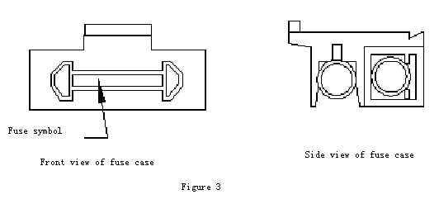
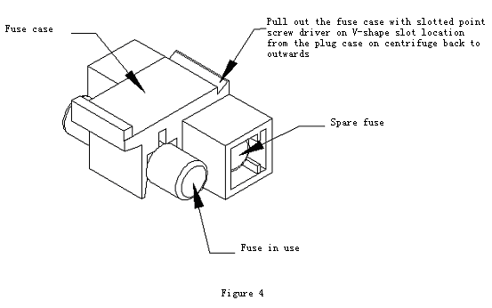

12、The common trouble and trouble shooting
12.1 Common error code : （Expect for error 4, must power off to clear other errors）
Error code | Description | Reasons | Solution
Error 6 | Overspeed | Overspeed, rotor number setting wrong or power control board can not be controlled | Check and replace
Error 6 | Overspeed | The acceleration profile value is too large when the load is exceeded | Turn down acceleration profile value
Error 5 | Door lid protection | The door lid isn’t closed when pressing [START]. | Close door lid properly
Error 5 | Door lid protection | The installed sensitive switch of door lid is not in place or damaged. | Check and replace
Error 7 | Motor does not run or runs without speed | Motor runs without speed; The speed-detecting signal is unreliable or the speed sensor is damaged. | Check and replace
Error 7 | Motor does not run or runs without speed | Motor does not run, and the shaft is blocked. | Replace motor
Error 7 | Motor does not run or runs without speed | Connecting terminal is loosened or power control board /drive module is damaged | Check and replace
Error 9 | Communication trouble | The connecting terminal of display board to power control board is loosened or power control board is damaged. | Check and replace
Form 5
If the centrifuge still can not work after removing the above several troubles, please contact with our company or service stations designated by our company.

13、Transportation and storage
13.1 Transportation
·You should use the wooden case and carton during long-distance transportation. Put centrifuge with dust cap into the case, and fill with foam or plastic shock absorption materials. It is forbidden to be hit, inverted, rolled and soaked by rain and snow.
·You can directly move the centrifuge in room, but avoid big vibration, hitting and inversion.
13.2 Storage
· If it is leaving unused for long time, you should open the door lid and store it in ventilated, dry and clean room where is no corrosive, flammable and explosive matters.
· As the technology continuously renews, please consult us if there is something unconformable with this instruction manual.

Warranty

Respected customers,
Thank you for purchase of our company’s products. To protect your legal rights and avoid your worries, we provide warranty service for one year with the main machines. If it is broken under warranty with inartificial reason, we will supply free maintenance service. The customer needs to pay an amount of money if the product has exceeded the warranty period. We will not supply free maintenance if any following matter is happened:
·Exceed of the warranty period or without the warranty card.
·The trouble is caused by wrong installation, operation and maintenance.
·The trouble is caused by the unauthorized uninstalling and repairing by our company.
· The trouble is caused by using the rotor not equipped with this centrifuge.
· The trouble is caused by war, natural disasters or other irresistible factors.

Packing List

Item | No | Name | Quantity | Unit | Remark | Check
Main machine | 1 | H1650 LCD | 1 | set
Option of rotor and accessories | 2 | Angle rotor 6x50ml | 1 | pc
Option of rotor and accessories | 3
Option of rotor and accessories | 4
Option of rotor and accessories | 5
Option of rotor and accessories | 6 | Power cord | 1 | pc | Power cord
Option of rotor and accessories | 7 | Fuse BGXP 5×20 | 5 | pc | 250V 10A
Attached tool | 1 | T-shaped inner hexagon spanner | 1 | pc
Attached tool | 2 | Door lid release tool | 1 | pc | Cross screw
Attached tool | 3
Attached file | 1 | Packing List | 1 | copy
Attached file | 2 | Instruction Manual | 1 | copy
Attached file | 3 | Qualified Certificate | 1 | copy
Attached file | 4

Checker:
Date:

Quality Certificate

Product Name： Tabletop High Speed Centrifuge

Product Model： H1650

Serial No.：

This product is tested and qualified for delivery.

Checker:
Date:

